Exoplanets and Stars
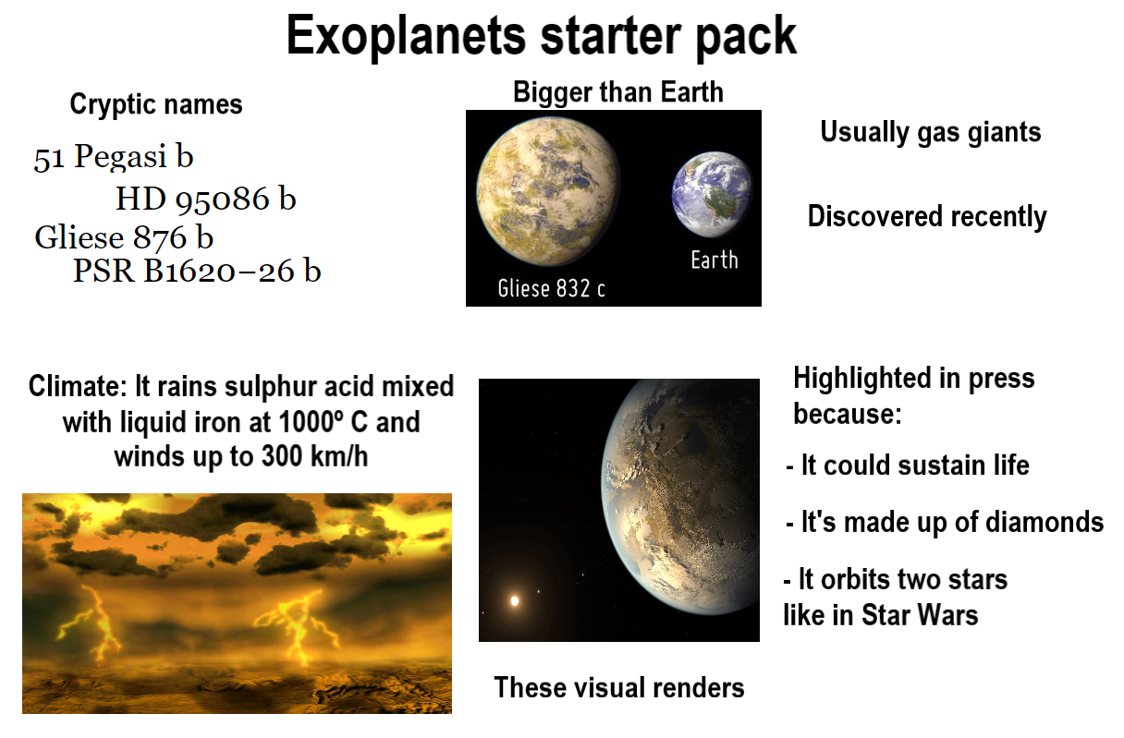Introduction
Background and Motivation
The discovery of exoplanets—planets orbiting stars beyond our solar system—has opened new frontiers in astronomy. These distant worlds offer a lens into planetary formation, evolution, and the conditions that might support life. This project investigates how stellar properties, such as mass, luminosity, and temperature, influence key planetary characteristics, particularly equilibrium temperature. Additionally, we assess how the detection method affects the observed properties of exoplanets. These questions are critical for understanding the formation and diversity of planetary systems across the galaxy.

Dataset Overview
This study uses observational data sourced from the NASA Exoplanet Archive, maintained by the California Institute of Technology under contract with NASA. The dataset includes 869 exoplanets and a wide array of associated stellar and planetary variables, allowing for both exploratory and statistical analysis.
The dataset provides rich, well-documented features, including:
- Stellar mass, radius, temperature, luminosity
- Planet mass, radius, orbital period, and equilibrium temperature
- Discovery method (e.g., Imaging, Radial Velocity)
This enables us to examine not only trends within individual variables, but correlations, group differences, and predictive relationships between stars and the host planets.

Research Questions
The main goal of this project is to explore the statistical relationships between stellar and planetary characteristics. Specifically, we address the following questions:
- How are stellar properties—mass, temperature, luminosity, and radius—correlated with one another?
This includes visualizing the Hertzsprung-Russell (HR) diagram using temperature, luminosity, and spectral type, as well as finding the mass-radius relationship of stars.
- How does the equilibrium temperature of an exoplanet relate to the stellar mass and stellar luminosity of its host star?
We use a multi-linear regression model to quantify the strength and nature of this relationship.
- Do exoplanets discovered by different methods (Imaging vs. Radial Velocity) differ significantly in their mass?
A t-test is used to explore whether the detection method influences the type of planets.

Variables and Visualization Methods
To address these questions, we use the following variables and statistical tools:
- HR Diagram (Scatterplot): Stellar temperature, luminosity, and spectral type
- Line Plot: Stellar radius vs. stellar mass
- Correlation Matrix + Regression Model:
  - Dependent variable: Planet equilibrium temperature
  - Independent variables: Stellar mass and stellar luminosity
- T-test: Planet mass grouped by discovery method (Imaging vs. Radial Velocity)

Data Explanation and Exploration

Data Wrangling
To prepare the dataset for analysis, we performed several cleaning and preprocessing steps using the dplyr and tidyverse packages in R:
- Column Renaming:
We used rename() to assign clearer, analysis-friendly names to variables. This improves readability and helps ensure consistency across plots and models.
- Column Selection:
Using select(), we filtered the dataset to retain only relevant variables for this study. This streamlines the dataset and avoids unnecessary computation.
- Data Type Adjustment:
The substr() function was applied to the stellar_spectype column to extract the first character of the spectral type. This categorization helps group stars by their temperature classes (e.g., A, F, G, K, M) and facilitate visualization.

Exploring Stellar Properties

HR Diagram: Stellar Luminosity vs. Temperature

The Hertzsprung–Russell (HR) diagram is a foundational tool in stellar astrophysics. It plots stellar luminosity (log scale) on the vertical axis against effective temperature on the horizontal axis.
- Stars with higher luminosity appear higher on the plot.
- Stars with higher temperature appear farther to the right (reverse x-axis scale).
- Color encodes spectral type, helping reveal stellar groupings.

Line Plot: Stellar Mass vs. Radius
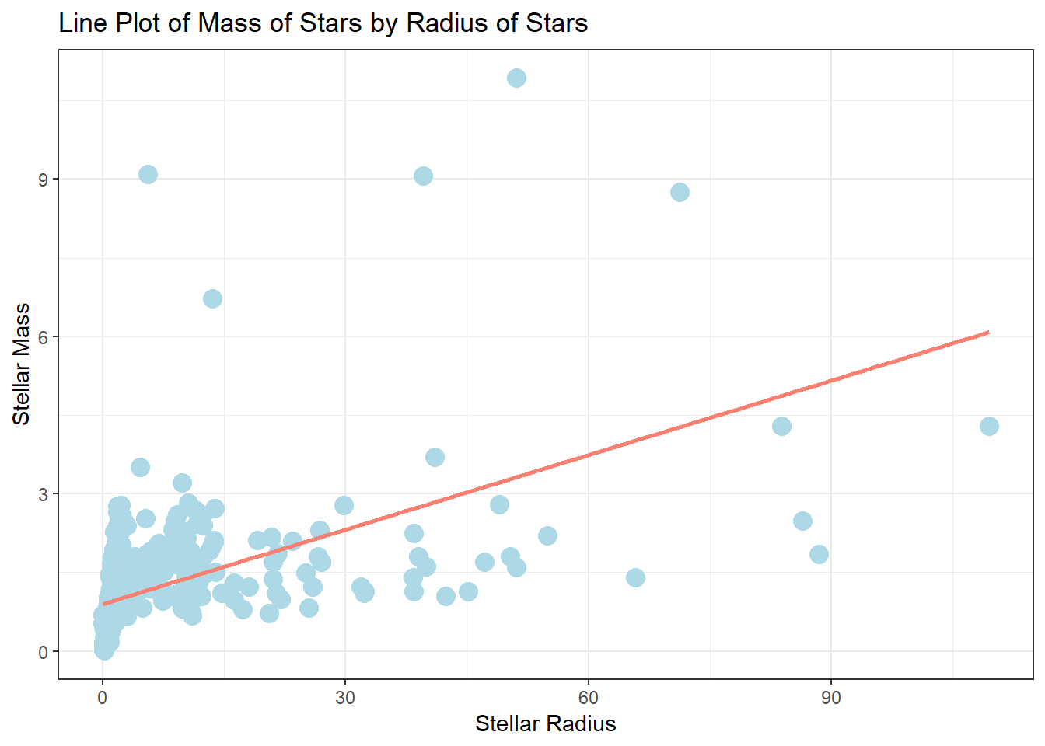
The plot has the relationship between stellar mass (y-axis) and stellar radius (x-axis):
- Each point represents an individual star.
- The regression line highlights a positive linear relationship—as radius increases, mass also tends to increase.
- This trend supports expected correlation between mass and size for main-sequence stars.
This analysis gives insights into the internal structure and composition of stars scale with size, aiding in modeling stellar dynamics and evolution.

Statistical Analysis and Interpretation

1. T-Test: Planet Mass by Discovery Method
To examine whether the method of discovery influences the mass of discovered exoplanets, we performed a t-test comparing planet masses detected by Imaging versus Radial Velocity.
Estimated Mean (Imaging) | 3937.4
Estimated Mean (Radial Velocity) | 1011.4
Statistic (t-value) | 10.08
P-value | <0.001
Degrees of Freedom (df) | 59.3
Confidence Interval Lower | 2345.2
Confidence Interval Upper | 3506.7
Method | Welch Two Sample t-test
Alternative | two.sided
Interpretation:
The p-value is below the 0.05 significance threshold, indicating a statistically significant difference in mean planet mass between the two methods. Planets discovered via Imaging tend to be significantly more massive than those detected by Radial Velocity. The confidence interval further confirms this result, as it does not contain zero.

Boxplot Validation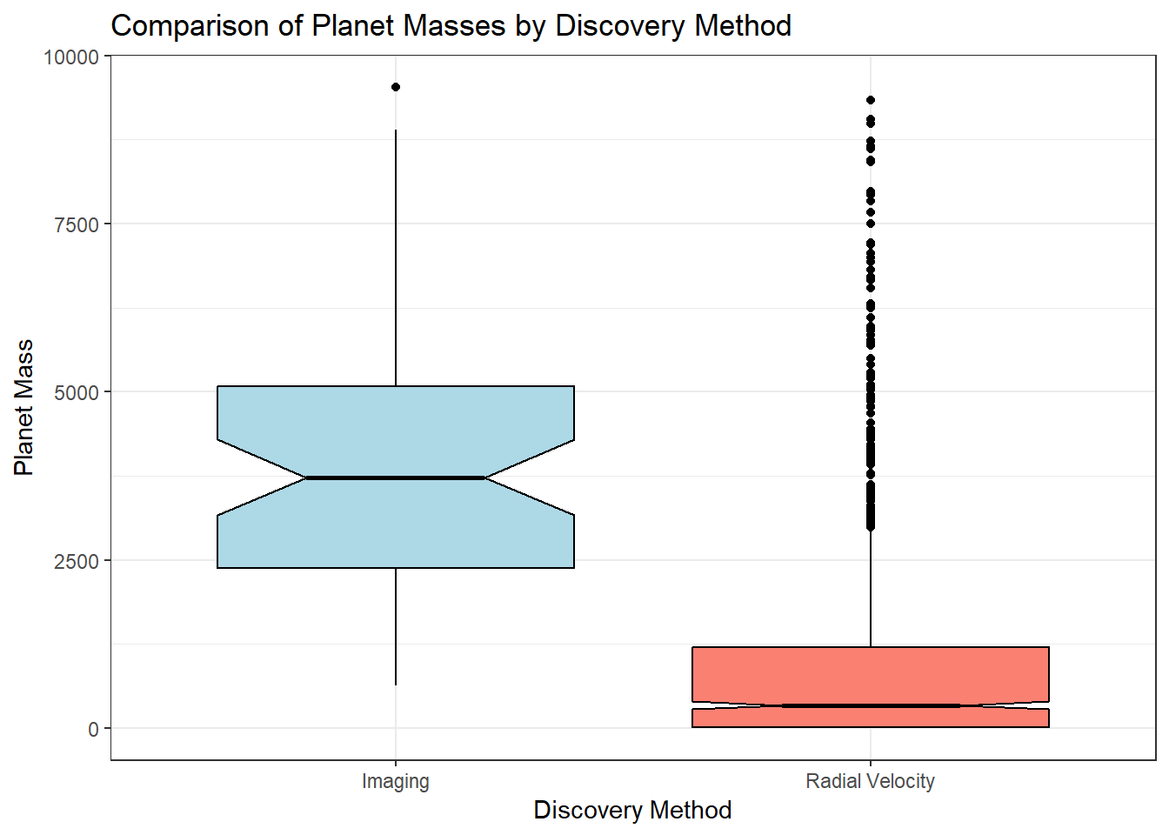
A corresponding box plot visualizes the mass distribution:
- The median and interquartile range are both higher for the Imaging group.
- The spread of masses is much larger for Imaging, consistent with its sensitivity to massive, distant planets.
Together, these findings reinforce the conclusion that detection methods influence the type of planets observed, likely due to instrumental and methodological sensitivity.

2. Correlation Among Stellar Variables
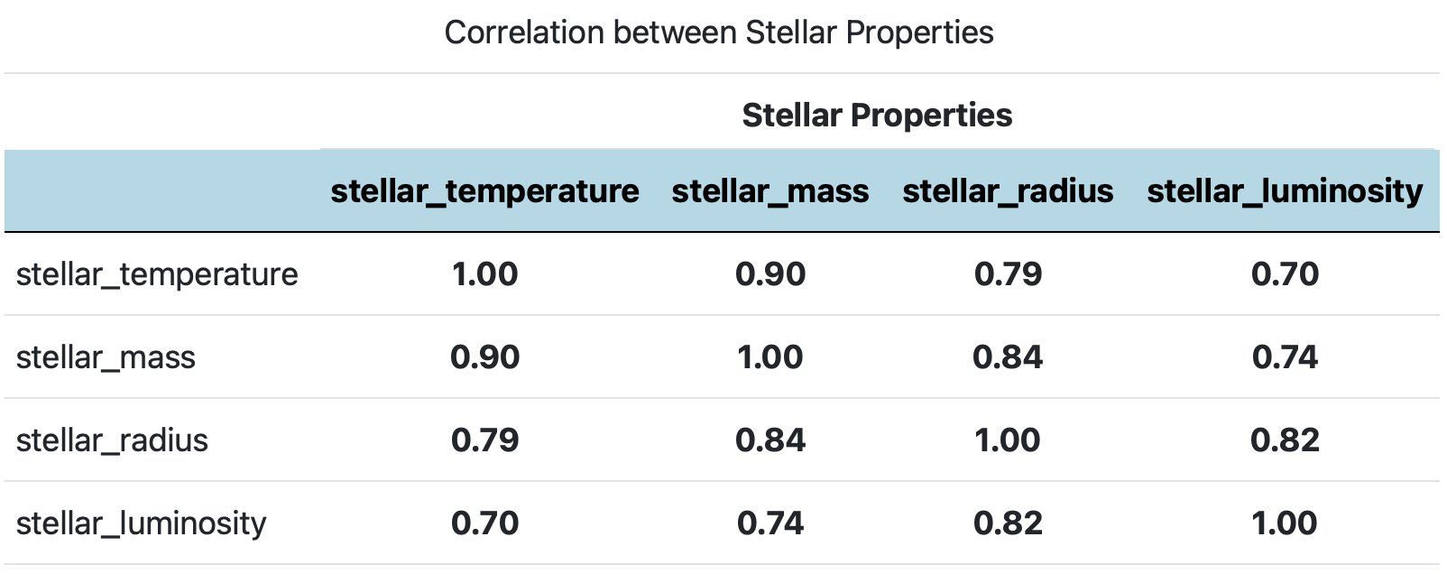
A correlation was computed for key stellar variables: mass, radius, temperature, luminosity.
- All variables show positive linear relationships, with coefficients from 0.70 to 0.90.
- The strongest observed correlation is in stellar temperature and stellar mass (r = 0.90).
Interpretation:
These strong correlations affirm the physical interconnectedness of stellar properties. More massive stars tend to be hotter, larger, and more luminous, which reflects well-established stellar structure theory and supports the use of these predictors in our regression modeling.

3. Chi-Square Test: Planet Size by Stellar Mass Group
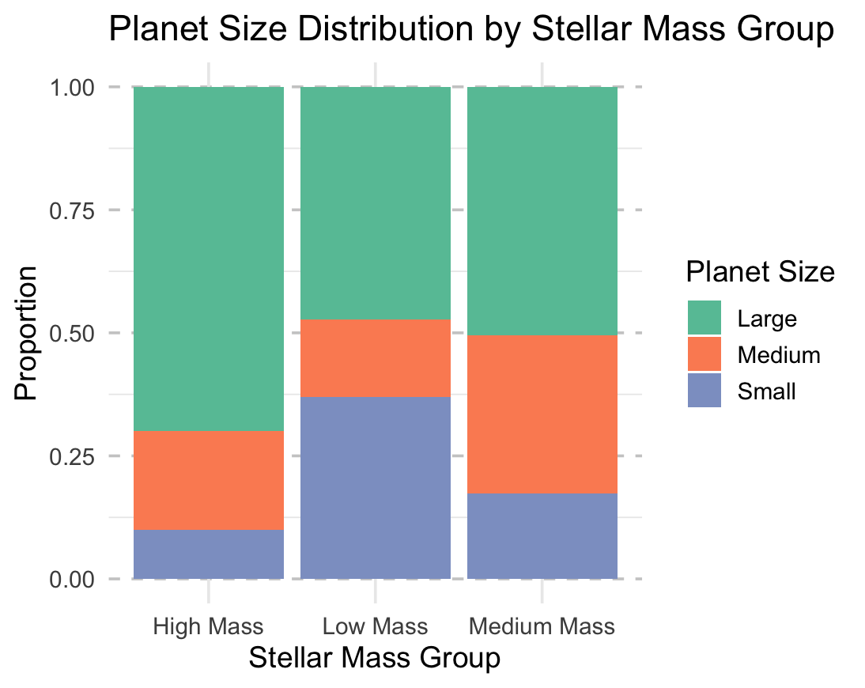
To assess whether the size of orbiting planets is associated with the stellar mass group of their host star, we binned both variables and conducted a Chi-Square Test.
- Chi-squared statistic (χ²): 53.5
- Degrees of Freedom: 4
- p-value: < 0.001
Interpretation:
The test result is highly significant, providing strong evidence of an association between stellar mass group and planet size category.
- Higher-mass stars are significantly more likely to host larger planets,
- while low-mass stars tend to have smaller planets.

Multivariate Regression Model
To examine how stellar properties influence a planet’s equilibrium temperature, we built a multiple linear regression model using stellar mass and stellar luminosity as predictors.

Model Specification
The model equation is: Temperature=β0​+β1​⋅Stellar Mass+β2​⋅log(Stellar Luminosity)
Model Coefficients
- Intercept(β0):
  - Estimate: 280.748 K
  - This represents the expected equilibrium temperature of a planet when both stellar mass and luminosity are zero (a theoretical baseline).
- Stellar Mass (β1):
  - Estimate: 733.779 K
  - Interpretation: For each additional solar mass unit of the host star, the planet’s temperature is expected to increase by ~733.8 K, holding luminosity constant.
- Stellar Luminosity (β2):
  - Estimate: 545.375 K
  - Interpretation: For each log-scale unit increase in stellar luminosity (in solar unit), temperature of the planet increases by ~545.4 K, holding stellar mass constant.
- R-squared (R²): 0.474
  - Indicates that approximately 47.4% of the variance in equilibrium temperature is explained by stellar mass and luminosity.

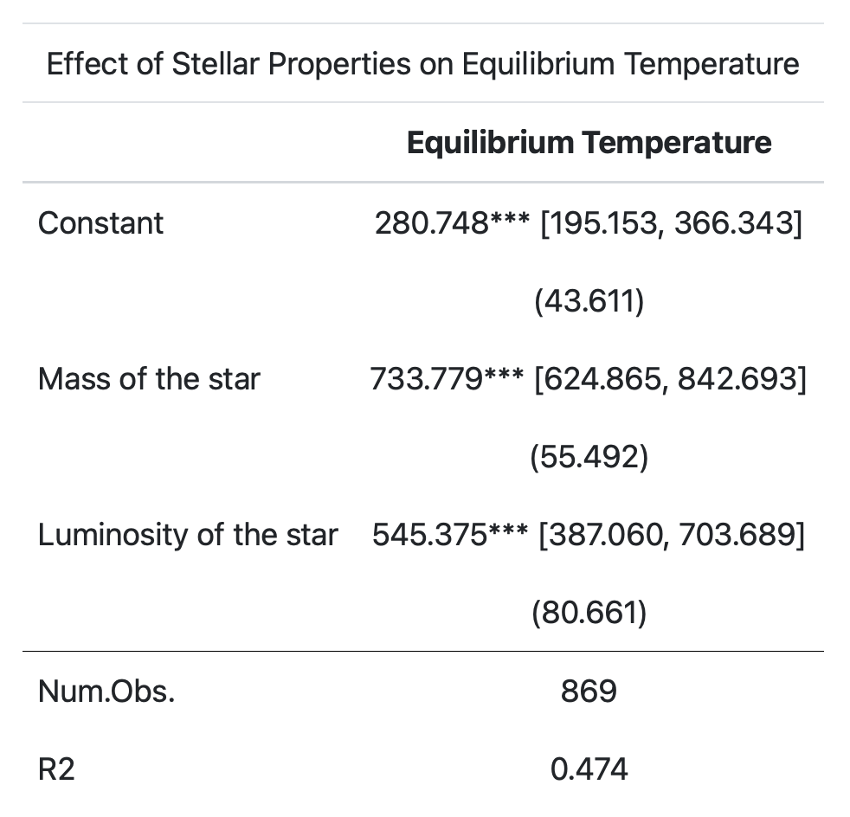

Residual Diagnostics
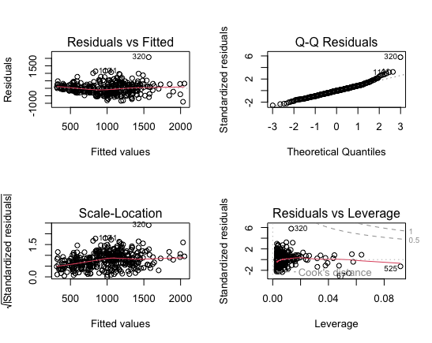
To evaluate the validity of the model assumptions, we assessed diagnostic plots:
- Residuals vs. Fitted:
  - No major curvature or pattern was observed, supporting the assumption of linearity. Slight funneling may suggest mild heteroscedasticity.
- Normal Q-Q Plot:
  - Residuals mostly follow a straight line, with slight deviation at the tails. Normality is reasonably satisfied.
- Scale-Location Plot:
  - The spread of residuals appears relatively constant across fitted values, supporting homoscedasticity.
- Residuals vs. Leverage:
  - No extreme outliers or influential observations were identified; most points fall well within Cook’s distance.

Interpretation
The regression model reveals a strong positive relationship between stellar characteristics and planetary equilibrium temperature. The significant coefficients and moderate R² value suggest that both stellar mass and stellar luminosity are meaningful predictors, consistent with theoretical models in astrophysics. Furthermore, residual analysis indicates that regression assumptions are largely met, supporting the model’s validity.

Conclusion
This study explored the relationships between stellar properties and planetary equilibrium temperatures using data from the NASA Exoplanet Archive. Through exploratory analysis, correlation testing, and regression modeling, we identified meaningful patterns that support current astrophysical understanding.
We found strong positive correlations between stellar mass, temperature, radius, and luminosity, all of which were consistent with theoretical expectations (Schneider & Arny, 2021). Our multiple regression model confirmed that stellar mass and luminosity significantly predict a planet’s equilibrium temperature, explaining approximately 47.4% of the variation. Residual analysis supported the validity of the model, though minor issues like non-normality and heteroscedasticity were noted.
A t-test showed a significant difference in planet mass based on the discovery method: Imaging techniques revealed significantly more massive planets than Radial Velocity, likely due to instrumental biases (NASA, 2024). A chi-square test reveals that higher-mass stars are more likely to host larger planets, consistent with theory.
Future work could improve modeling by incorporating nonlinear terms, interaction effects, or advanced methods such as machine learning. Adding variables like atmospheric composition, orbital eccentricity, or albedo would provide a more complete picture of planetary diversity (Palen & Blumenthal, 2022).
As astronomical datasets continue to grow, the integration of statistics and astrophysics will be essential to uncover the complexity of planetary systems.

References
- ESA Science & Technology. (2019). Searching for exoplanetary systems
- NASA Exoplanet Archive. (2024). Planetary systems composite data. Link
- Palen, S., & Blumenthal, G. (2022). 21st Century Astronomy. W. W. Norton & Company.
- Schneider, S. E., & Arny, T. (2021). Pathways to Astronomy. McGraw-Hill Education.

